Name of the Experiment : Study of diode Half-Wave rectifier circuit.

Equipment:

1. Diode ( 1 piece )
2. Signal Generator ( 1 piece )
3. Resistor ( 10k Ω , 1 piece )
4. Oscilloscope ( 2 piece )

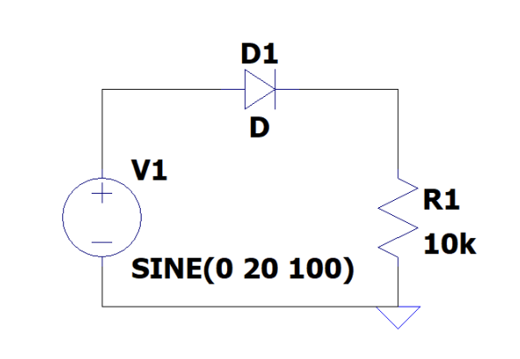

Circuit : Simulation :

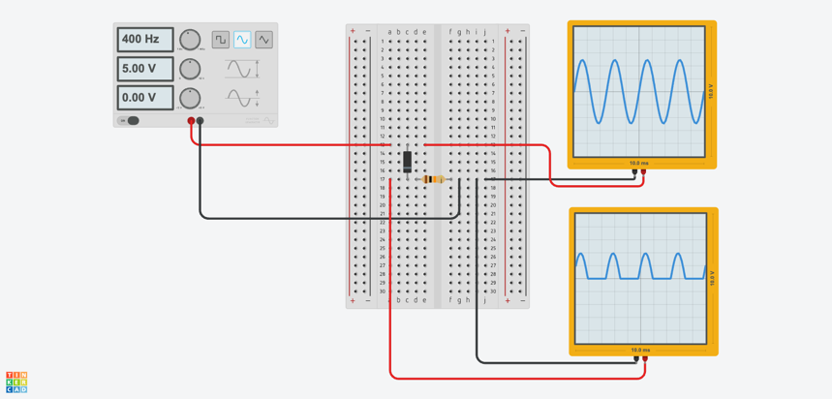

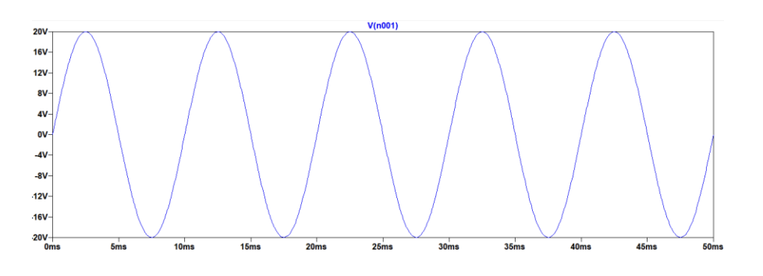

Input Voltage :

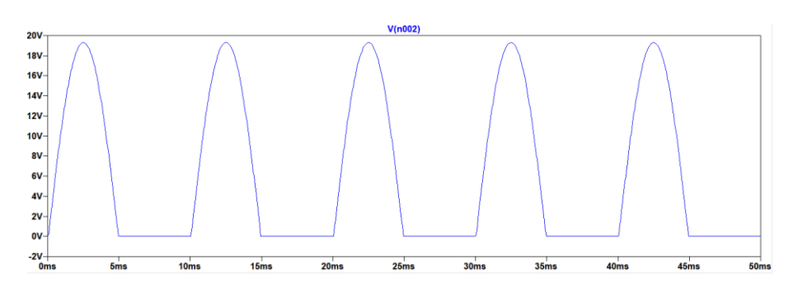

Output Voltage :

Summary:

Here, the input voltage is a sine function with an amplitude 20 V & frequency 100 Hz. The value of the resistor is 10 KΩ. The load receives approximately half of the input power